1. ***What is the process of Data Analysis?***
2. **Understanding the Problem:** Understand the business problem, define the organizational goals, and plan for a lucrative solution.
3. **Collecting Data:** Gather the right data from various sources and other information based on your priorities.
4. **Cleaning Data:** Clean the data to remove unwanted, redundant, and missing values, and make it ready for analysis.
5. **Exploring and Analyzing Data:** Use data visualization and business intelligence tools, data mining techniques, and predictive modeling to analyze data.
6. **Interpreting the Results:** Interpret the results to find out hidden patterns, future trends, and gain insights.
7. ***What do you understand by BI? Or what is BI?***

The term Business Intelligence refers to a collective meaning, including technologies, tools, applications, practices for the data collection, and providing those data to the users, especially to help in running the business or a part of it.

In other words, the business analyst’s reports generated and compiled using the Business Intelligence approaches are consumed by the higher management administrative and business executives to make better decisions for the overall maturity of the business.

1. ***Do you know of other BI platforms? How does Power BI compareto them?***

**The popular Business Intelligence (BI) tools used by Business Analysts are:**

1. Microsoft BI
2. Cognos
3. MicroStrategy
4. Tableau
5. SAS
6. Business Objects
7. OBIEE
8. Hyperion

## **Power BI vs Tableau: Key Differences**

**Power BI is easy to learn as compared to Tableau.**

* It allows you to create new columns, delete unnecessary columns, modify data, change formats, etc., but Tableau allows you to work on pre-processed data itself. Users can alter the data type and split columns, but they cannot remove unnecessary columns.
* Power BI focuses on the “flow” to have a smooth and consistent user experience. On the other hand, Tableau focuses on coding to provide you with new visual effects which third parties create.
* Power BI uses DAX for calculating and measuring columns, while Tableau deploys MDX for measures and dimensions.
* Power BI offers PowerPivot dots (user to perform efficient data analysis) more user-accessible, but Tableau does not provide this.
* <https://www.interviewbit.com/blog/power-bi-vs-tableau/>

1. ***What is the difference between supervised and unsupervised learning?***

*** Supervised learning uses data that is completely labeled, whereas unsupervised learning uses no training data.

**Extra:**

There are three types of machine learning:

#### Supervised Learning

In supervised machine learning, a model makes predictions or decisions based on past or labeled data. Labeled data refers to sets of data that are given tags or labels, and thus made more meaningful.

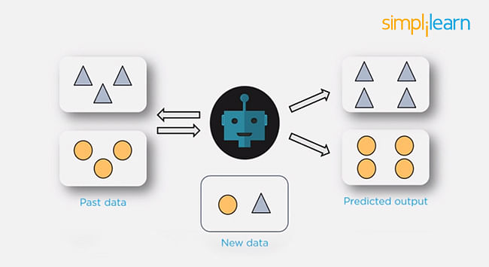

#### Unsupervised Learning

In unsupervised learning, we don't have labeled data. A model can identify patterns, anomalies, and relationships in the input data.

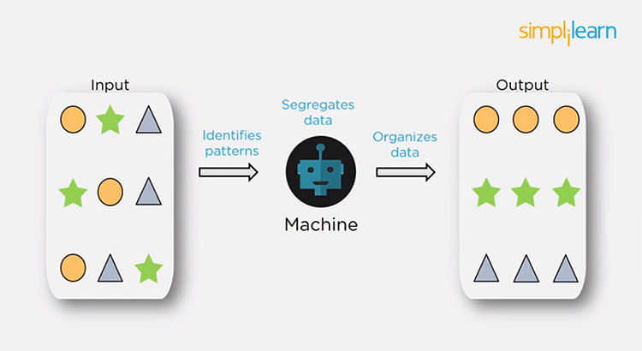

#### Reinforcement Learning

Using [reinforcement learning](https://www.simplilearn.com/tutorials/machine-learning-tutorial/reinforcement-learning), the model can learn based on the rewards it received for its previous action.

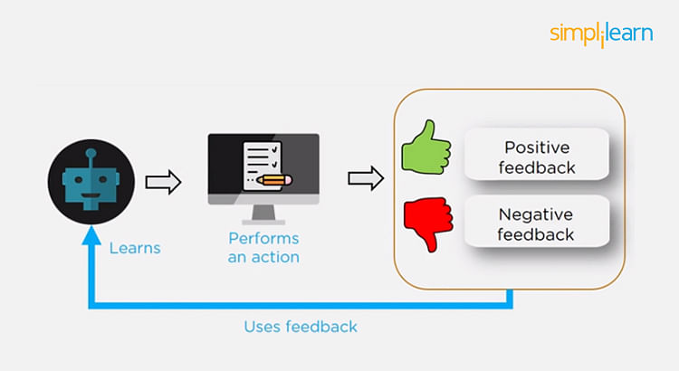

Consider an environment where an agent is working. The agent is given a target to achieve. Every time the agent takes some action toward the target, it is given positive feedback. And, if the action taken is going away from the goal, the agent is given negative feedback.

1. ***What is the central limit theorem?***

The Central Limit Theorem states that the sampling distribution of the mean of a large number of independent, identically distributed random samples will approach a normal distribution, regardless of the original population’s distribution.

(Central Limit Theorem states that when ***large samples usually greater than thirty are taken into consideration then the distribution of sample arithmetic mean approaches the normal distribution irrespective of the fact that random variables were originally distributed normally or not.)***